California Native Grasslands Association: Learning About California Grasslands
Lesson Title: Mammals in California Grasslands: Kangaroo Rat
Grade level: Early and late elementary
Lesson Length: 25 minutes
Preparation and Materials: Copies of worksheet, pencil
Lesson Goal: Students practice reading comprehension while learning about a California grassland species.
Lesson Description: Lower early elementary: The teacher reads the paragraph to the students and leads students in answering the questions, defining vocabulary terms, and discussing the paragraph.
Upper early elementary: Students read the paragraph and complete the lesson by answering the questions.
Lesson Objectives: Students read a paragraph about the kangaroo rat, answer questions about what they have read, and label a diagram of a kangaroo rat burrow. Students learn about this grassland species’ habitat and behavior.
Lesson Background: There are about a dozen species of kangaroo rat in California, and several are endemic, meaning that they can only be found in California. Development and agriculture of grassland habitats used by kangaroo rats has resulted in the endangerment of several species. In addition, while native perennial grasslands have “patchy” grass structure, non-native annual grasses which now dominate many Californian grasslands form thick mats which are difficult for kangaroo rats to forage in and reduce the quality of habitat for kangaroo rats. Conservation efforts focus on preserving kangaroo rat grassland habitats and managing weedy plant species.
(Information from: Goldingay, R. L., Kelly, P. A., & Williams, D. F. (1997). The kangaroo rats of California: endemism and conservation of keystone species. Pacific Conservation Biology, 3(1), 47.)
Vocabulary Words:
Nocturnal – An animal which is primarily active at night and sleeps during the day
Forage – To search for food
Solitary – An organism that mainly lives alone
Predator – An animal which hunts and eats other animals
Mammals in California Grasslands Name__________________________
Kangaroo Rats (Dipodomys species)

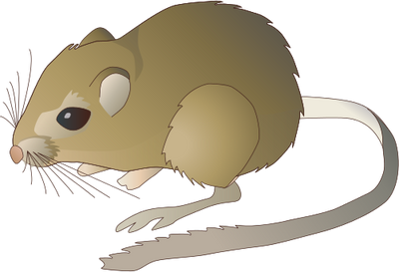
Several species of kangaroo rats, or “K-rats”, live in California grasslands. Like kangaroos, they have large hind limbs they use to hop from place to place, and a long tail to help them balance. Kangaroo rats are nocturnal species, which means they spend their days resting in their burrows. They come out at night to forage for seeds, which they carry home to their burrows in their expandable cheek pouches. They pile the seeds near their burrow entrances to allow them to dry. Once the seeds are dry, the kangaroo rats move them deeper into the burrows for storage. Their burrows are complex systems with different chambers, or “rooms” for sleeping, raising young, and storing food. Kangaroo rats plug the burrow entrance with dirt during the day to control the temperature and humidity of their burrows. They also take dust baths to cool and clean themselves. Kangaroo rats are mostly solitary species, but they communicate with one another by thumping their feet on the ground like Morse code. The dens and burrows that kangaroo rats build are sometimes used for shelter by other animals, such as mice, snakes, lizards, and insects. Predators of kangaroo rats include owls, foxes, badgers, coyotes, and bobcats.

- What do kangaroo rats use their cheek pouches for?

- Why do you think these species are called “kangaroo rats”?

- What are two ways kangaroo rats keep cool?

- How do kangaroo rats talk to one another?

Mammals in California Grasslands Name__________________________
Kangaroo Rats (Dipodomys species)

What do you think each of the three burrow “rooms”, or chambers, are being used for in the picture below? Draw arrows to each of the three chambers and describe what is happening in them, based on what you read.

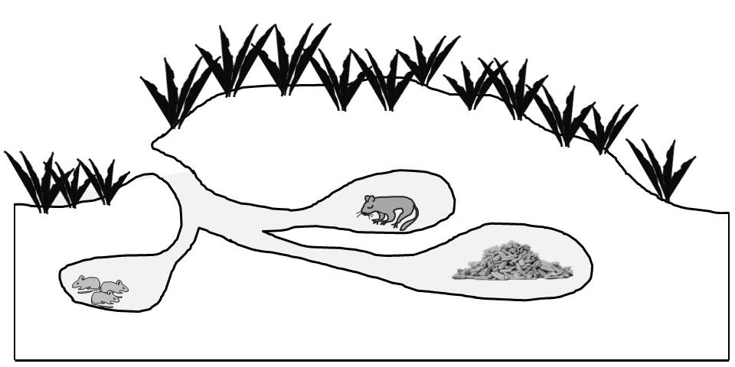

Mammals in California Grasslands TEACHER’S KEY
Kangaroo Rats (Dipodomys species)

Several species of kangaroo rats, or “K-rats”, live in California grasslands. Like kangaroos, they have large hind limbs they use to hop from place to place, and a long tail to help them balance. Kangaroo rats are nocturnal species, which means they spend their days resting in their burrows. They come out at night to forage for seeds, which they carry home to their burrows in their expandable cheek pouches. They pile the seeds near their burrow entrances to allow them to dry. Once the seeds are dry, the kangaroo rats move them deeper into the burrows for storage. Their burrows are complex systems with different chambers, or “rooms” for sleeping, raising young, and storing food. Kangaroo rats plug the burrow entrance with dirt during the day to control the temperature and humidity of their burrows. They also take dust baths to cool and clean themselves. Kangaroo rats are mostly solitary species, but they communicate with one another by thumping their feet on the ground like Morse code. The dens and burrows that kangaroo rats build are sometimes used for shelter by other animals, such as mice, snakes, lizards, and insects. Predators of kangaroo rats include owls, foxes, badgers, coyotes, and bobcats.

- What do kangaroo rats use their cheek pouches for?

They use them to collect and carry seeds when foraging.

- Why do you think these species are called “kangaroo rats”?

They have large hind limbs which they hop on, and a long tail.

- What are two ways kangaroo rats keep cool?

They take dust baths, and control the temperature of their burrows by plugging the entrance with dirt.

- How do kangaroo rats talk to one another?

By thumping their feet on the ground.

Mammals in California Grasslands TEACHER’S KEY
Kangaroo Rats (Dipodomys species)

What do you think each of the three burrow “rooms”, or chambers, are being used for in the picture below? Draw arrows to each of the three chambers and describe what is happening in them, based on what you read.

Top chamber: Used for sleeping
Bottom left chamber:Used for raising offspring
Bottom right chamber: Used for storing seeds

